Name: Date:

Midterm Performance Assessment/ Portfolio Entry
In this performance assessment, you will demonstrate your ability to:
- Organize, summarize, and interpret single-variable data using descriptive methods of statistics.
- Recognize and apply the different representations of quantitative information (e.g. symbolic, visual, numerical, verbal) when describing relationships between two variables and building predictive models using correlation and regression.
- Utilize statistics software to perform data analyses to interpret and compare multiple representations of quantitative information and draw inference from them.
- Communicate quantitative information effectively incorporating symbolic, numeric, and/or graphical representations and appropriate syntax within verbal and written communication.

- Open the Body Mass Index data set in the statistics software package of your choice (SeeIt, StatCrunch, Excel, etc.). (Statcrunch: http://www.statcrunch.com/app/index.php?dataid=1754263) Using descriptive methods of statistics:
  - Organize the data into two graphs (i.e., dotplots or histograms) to display the Body Mass Index of the males and of the females.
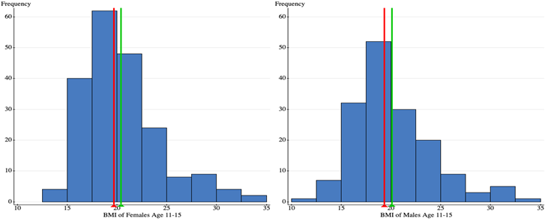

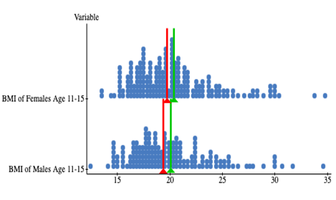
  - Create boxplots for each set of data.
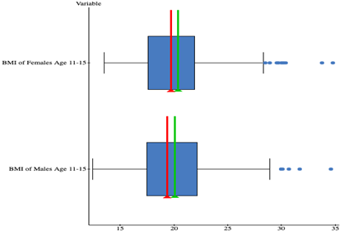
  - Write a paragraph to communicate quantitative information about the two sets of data. Describe the shape, center, and variation of each data set. Compare the BMI of the males to the BMI of the females. Reference your visualizations to support the claims you make about the similarities and differences in the data.
The BMI data for the male has a right-skewed shape as shown by the tail on the graphs which extends to the right. The data set center is determined through the median which is 19.35 while the variation is represented by the IQR of 4.7. Similarly, the BMI data for the female has a right-skewed shape as depicted by the tail on the graphs which extend to the right. The data set center is determined by the median which is 19.7 and the variation is represented by the IQR of 4.3. Typically, the male BMI is slightly lower than that of the females. Females have a slightly lower variation in BMI than the males do.
- Open the Body Mass vs. Waist Size data set in the statistics software package of your choice (SeeIt, StatCrunch, Excel, etc.). (Statcrunch: http://www.statcrunch.com/app/index.php?dataid=1754278) Using descriptive methods in correlation and regression:
  - Organize the data into a graph (i.e., scatterplot) that displays the relationship between BMI and waist size.
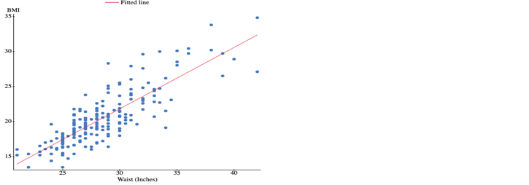
  - Calculate the correlation coefficient. Identify the equation of the regression line, and calculate the coefficient of determination.
Correlation coefficient = 0.837
Regression line equation, y= -4.468 + 0.876x
Determination coefficient = 0.700
  - Choose two values for the explanatory variable (within the scope of the model) and use the regression line equation to predict the associated values of the response variable.
22.701= -4.468 + 0.876(31)
18.319 = -4.468 + 0.876(26)
  - Write a paragraph to communicate quantitative information about the relationship between the two variables. Identify which variable is the explanatory variable and which is the response variable. Describe the strength and direction of the relationship between the explanatory and response variables. Explain the regression line equation – what is the meaning of the slope and the y-intercept in your model? Identify the coefficient of determination and explain the meaning of that value. Refer to your visualization to support the claims you make about the relationship between the explanatory and response variables.
Under this circumstance, the explanatory variable is 18.319 while the response variable is 22.701. The response variable increases in response to an increase in the x-intercept. This implies that the response variable will be stronger compared to the explanatory variable due to the increase in the value of the x-intercept. The general equation of a straight line is y = mx +c which imply that 0.876 is the slope of the line while -4.468 is the constant. The coefficient of determination is 0.700.
- Refer to the data scenario below. Using descriptive methods of statistics, discuss the quantitative results in the context of the problem.
Five track athletes are in the running for the Athletic Performance of the Year award. A panel of coaches is trying to decide which athlete is the most deserving to win the award. Assume all distributions follow a Normal Curve.
Javier – threw the javelin 215 ft. For javelin throws, µ = 152.08 ft. and σ = 15.85 ft.
Chance – ran a 400m time of 46.99 sec. For 400m runs, µ = 52.6 sec. and σ = 1.01 sec.
Derick – ran a 36.26 sec. time in the hurdles. For hurdles, µ = 41.77 sec. and σ = 1.49 sec.
Chad – ran a 100m time of 10.59 sec. For 100m runs, µ = 11.603 sec. and σ = 0.29 sec.
Kayden – threw the discus 180 ft. For discus throws, µ = 122.4 ft. and σ = 14.38 ft.
  - Calculate a standard score for each athlete’s performance.
X | Mean | Standard Deviation | z | Mod z
215.00 | 152.08 | 15.85 | 3.970 | 3.970
46.99 | 52.60 | 1.01 | -5.554 | 5.554
36.26 | 41.77 | 1.49 | -3.698 | 3.698
10.59 | 11.60 | 0.29 | -3.493 | 3.493
180.00 | 122.40 | 14.38 | 4.006 | 4.006

  - Compare the standard scores to rank the athletes.
Rank | Event/Name | Mod z
1 | 400m run | 5.55
2 | Discuss toss | 4.00
3 | Javelin toss | 3.97
4 | Hurdles | 3.70
5 | 100m run | 3.49

  - Write a paragraph to communicate quantitative information about the relative performance of these athletes. Make appropriate references to the player’s achievements and their standard scores in your defense to the claims you make about which athlete’s performance is the most spectacular.
For the case of higher X, it is preferred in the javelin toss and discus. On the other hand, lower x is preferred for the hurdles, 400m and the 100m run. Therefore, modified z signs switched on the events.

Statistics and Reasoning I Midterm Performance Assessment Grading Scheme

- Organize, summarize, and interpret single-variable data using descriptive methods of statistics.
Problem 1:
- Side-by-side dotplots, histograms, or other visualizations accurately display given data.
- Boxplots demonstrate correct min, max, Q1, median, and Q3 for each set of data.
- Paragraph includes information about:
  - Shape of each distribution
  - Center of each distribution
  - Spread of each distribution
Problem 3:
- Standard scores (z-scores) are correctly calculated for each scenario.
- Standard scores are correctly compared and ranked.

- Recognize and apply the different representations of quantitative information (e.g. symbolic, visual, numerical, verbal) when describing relationships between two variables and building predictive models using correlation and regression.
Problem 2:
- Scatterplot correctly displays explanatory and response variables.
- Correlation coefficient is identified correctly. The strength and direction of the relationship is explained.
- Coefficient of determination is identified correctly. The proportion of the model that can be explained by the linear model is explained.
- Regression line equation is identified correctly. Two points within the scope of the model are predicted using the regression equation.
- The meaning of the slope is explained; the reasonableness of interpreting the intercept is identified.

- Utilize statistics software to perform data analyses to interpret and compare multiple representations of quantitative information and draw inferences from them.
Problem 1 and 2:
- A statistics software package is utilized. Screenshots or other evidence of its use present.

- Communicate quantitative information effectively incorporating symbolic, numeric, and/or graphical representations and appropriate syntax within verbal and written communication.
Problem 1:
- Paragraph comparing the data sets is coherently written. It includes:
  - Comparison of similarities and differences in the distributions
  - References to visualizations
Problem 2:
- Paragraph explaining the relationship between the explanatory and response variables is coherently written. It includes:
  - Explanation of the symbolic representation of the regression equation
  - References to the graphical representation of the correlation data
Problem 3:
- Paragraph describing the data scenario is coherently written. It includes:
  - Discussion of the quantitative results in the context of the problem

